**1. Connecting to EC2 Using the AWS Console (EC2 Instance Connect)**

**Prerequisites:**

* Your EC2 instance must be **running**.
* Your EC2 instance should have **SSH** access enabled (for Linux) or **RDP** access enabled (for Windows) through the security group.
* **IAM permissions** for EC2 Instance Connect must be granted.

**Steps to Connect Using the Console (for Linux Instances):**

1. **Log in to the AWS Console:**
   * Go to the [AWS Management Console](https://aws.amazon.com/console/) and sign in.
2. **Navigate to EC2 Dashboard:**
   * In the console, search for **EC2** and open the **EC2 Dashboard**.
3. **Select the Instance:**
   * In the left sidebar, click on **Instances** under the **Instances** section.
   * Find and select the **running EC2 instance** you want to connect to.
4. **Click on "Connect":**
   * With the instance selected, click on the **Connect** button at the top of the screen.

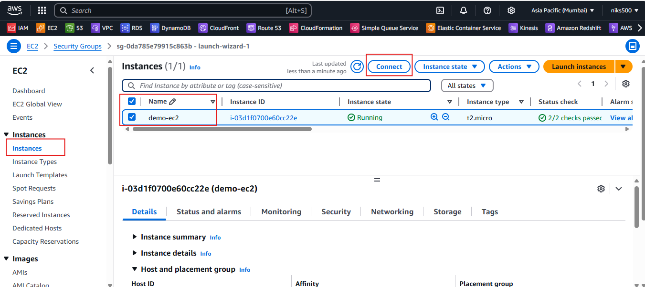

1. **Choose EC2 Instance Connect (Browser-Based SSH):**
   * In the **EC2 Instance Connect** section, click on **Connect**. This will open an SSH session directly in your browser without needing an external terminal.
   * If prompted, click **Connect** again to launch the connection.

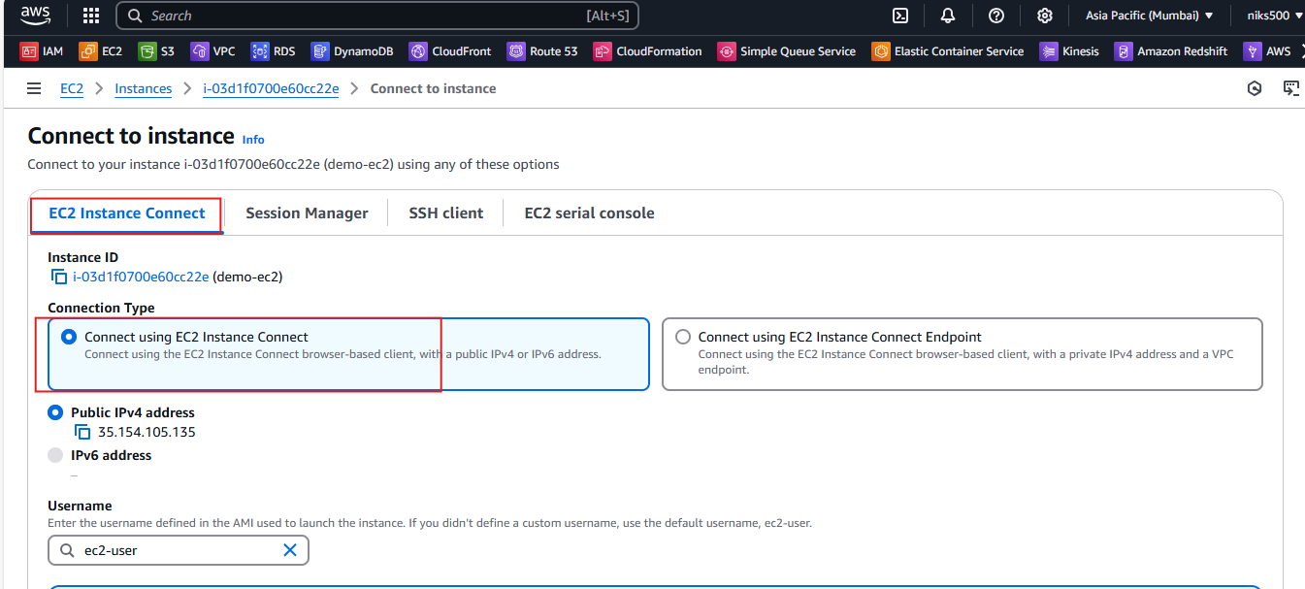

**For Windows Instances:**

* + If your instance is Windows-based, instead of using SSH, click on the **RDP** tab.
  + Download the **RDP file** and retrieve the **administrator password** using your PEM key.
  + Use an RDP client to connect to the instance.